Practical Lab Experiment 1
- Installation of JDK environment & following utilities. What is javac , javap and javadoc.
Description:
1. Installation of JDK Environment
The Java Development Kit (JDK) is required to write, compile, and run Java programs.
To install the JDK, follow these steps:
Step 1: Download JDK
• Visit Oracle’s official website or OpenJDK website
• Download the latest version of JDK for your operating system (Windows, Linux, macOS)
Step 2: Install JDK
• Run the installer
• Follow the installation wizard
• Default installation path (Windows):
• C:\Program Files\Java\jdk<version>
Step 3: Set Environment Variables
To make Java accessible from any directory:
Add JAVA_HOME
JAVA_HOME = C:\Program Files\Java\jdk<version>
Add Java to PATH
Add the following to the PATH variable:
%JAVA_HOME%\bin
Step 4: Verify Installation
Open Command Prompt:
java -version
javac -version
If both run successfully, the JDK is installed correctly.

2. Java Utilities (javac, javap, javadoc)
A) javac
• javac is the Java compiler.
• It converts the .java (source file) into .class (bytecode).
• Syntax:
• javac FileName.java
B) javap
- javap is the Java Class File Disassembler.
- It shows information about the compiled class, such as:
- methods
- fields
- bytecode
- Syntax:
- javap FileName
C) javadoc
- javadoc is the documentation generator.
- It creates HTML documentation from Java source files that include comment blocks
- Commonly used for generating API documentation.
- Syntax:
javadoc FileName.java

Code:
public class simpleprogram
{
private int value;
public String pbS1;
float num1;
protected Boolean b1;
public simpleprogram(int value,String pbS1,float num1, Boolean b1) {
this.value = value;
this.pbS1 = pbS1;
this.num1 = num1;
this.b1 = b1;
}

public int getValue() {
return value;
}

public void setValue(int value) {
this.value = value;
}
}

Output:
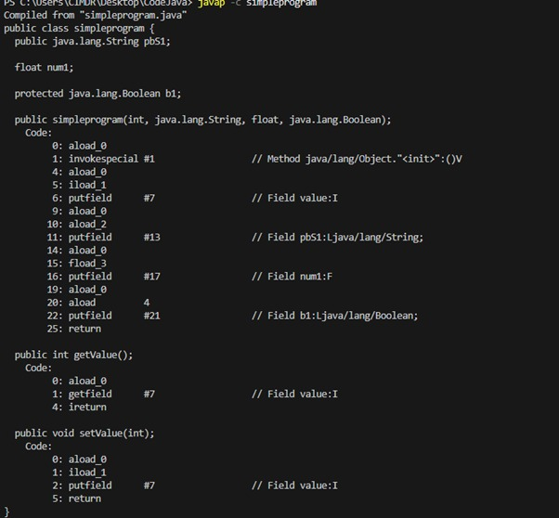
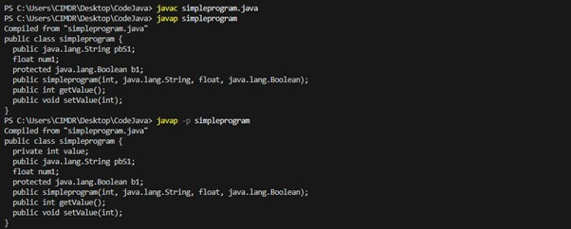

Practical Lab Experiment 2
2. Write a Program to design a Java application using array.
(Implement Sorting of given list of names in ascending order).

Code:
import java.util.*;

public class NameSorter {
public static void main(String[] args) {
Scanner sc = new Scanner(System.in);
int n = 0;

while (true) {
System.out.print("Enter number of names: ");
if (sc.hasNextInt()) {
n = sc.nextInt();
sc.nextLine(); // consume newline
break;
} else {
System.out.println("Please enter a valid number!");
sc.nextLine(); // clear invalid input
}
}

String[] names = new String[n];
for (int i = 0; i < n; i++) {
System.out.print("Enter name " + (i+1) + ": ");
names[i] = sc.nextLine();
}

Arrays.sort(names);

System.out.println("\nSorted names:");
for (String name : names) {
System.out.println(name);
}
}
}

Output:
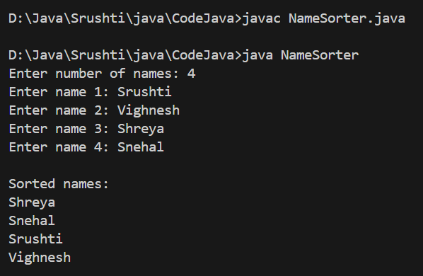

Practical Lab Experiment 3
3. A. Write a Java program for Implementation of functionality provided by any five built in Java API / packages.
B. Implementation of custom defined Package – Illustrate the visibility of classes and their members in packages using different access modifiers.

Code:
import java.io.*; // Scanner, Collections
import java.lang.*; // File handling
import java.math.*; // Date and Time
import java.time.*; // BigInteger
import java.util.*; // Math, String

public class BuiltinDemo {
public static void main(String[] args) throws IOException {
Scanner sc = new Scanner(System.in);

// java.util
System.out.println("Enter three numbers: 45 12 78");
List<Integer> numbers = Arrays.asList(45, 12, 78);
Collections.sort(numbers);
System.out.println("Sorted numbers: " + numbers);

// java.io
File file = new File("demo.txt");
file.createNewFile();
System.out.println("File created: " + file.getName());

// java.time
LocalDate today = LocalDate.of(2025, 11, 30);
LocalTime now = LocalTime.of(17, 40, 12);
System.out.println("Today's date: " + today);
System.out.println("Current time: " + now);

// java.math
BigInteger big1 = new BigInteger("12345678901234567890");
BigInteger big2 = new BigInteger("98765432109876543210");
System.out.println("BigInteger sum: " + big1.add(big2));

// java.lang
double sqrtVal = Math.sqrt(144);
System.out.println("Square root of 144: " + sqrtVal);
}
}

Output:
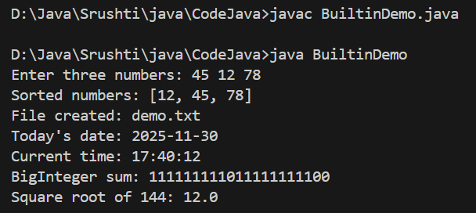

Practical Lab Experiment 4
4. Program using Abstract Class:
Write a java program to create an abstract class named Shape that contains two integers and an empty method named printArea().

Code:
import java.util.Scanner;

abstract class Shape {
private int param1;
private int param2;

abstract void printArea();

public void setparam1(int num1) {
param1 = num1;
}
public int getparam1() {
return param1;
}
public void setparam2(int num) {
param2 = num;
}
public int getparam2() {
return param2;
}
}

class Rectangle extends Shape {
Rectangle(int num1, int num2) {
this.setparam1(num1);
this.setparam2(num2);
}
public void printArea() {
System.out.println("Area of Rectangle : " + this.getparam1() * this.getparam2());
}
}

class Triangle extends Shape {
Triangle(int base, int height) {
this.setparam1(base);
this.setparam2(height);
}

public void printArea() {
System.out.println("Area of Triangle : " + (0.5 * this.getparam1() * this.getparam2()));
}
}

class Circle extends Shape {
Circle(int radius) {
this.setparam1(radius);
}
public void printArea() {
System.out.println("Area of Circle : " + (Math.PI * this.getparam1() * this.getparam1()));
}
}

public class InterfaceShape {
public static void main(String[] args) {
Scanner s = new Scanner(System.in);

System.out.println("Enter the length and breadth for Rectangle: ");
int l = s.nextInt();
int b = s.nextInt();
Rectangle r = new Rectangle(l, b);
r.printArea();

System.out.println("\nEnter the base and height for Triangle: ");
int base = s.nextInt();
int height = s.nextInt();
Triangle t = new Triangle(base, height);
t.printArea();

System.out.println("\nEnter the radius for Circle: ");
int radius = s.nextInt();
Circle c = new Circle(radius);
c.printArea();
}
}

Output:
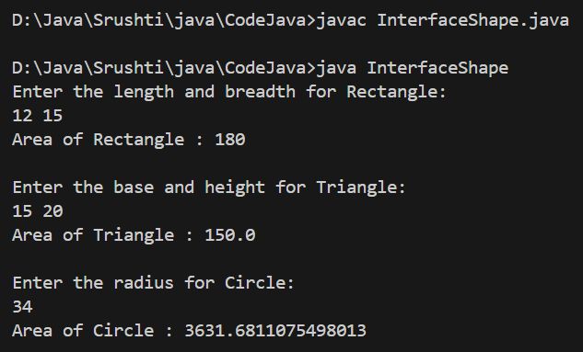

Practical Lab Experiment 5
5. Write a java program to illustrate the use of Interface.

Code:
interface Machine {
void assign(); // First method
void details(); // Second method (Newly added)
}
class Laptop implements Machine {
public void assign() {
System.out.println("Laptop Assigned");
}
public void details() {
System.out.println("Laptop: 16GB RAM, i5 Processor");
}}
class Desktop implements Machine {
public void assign() {
System.out.println("Desktop Assigned");
}
public void details() {
System.out.println("Desktop: 8GB RAM, i3 Processor");
}}
class Tab implements Machine {
public void assign() {
System.out.println("Tablet Assigned");
}
public void details() {
System.out.println("Tablet: 4GB RAM, Android OS");
}}
class Employee {
String name;
int id;
Employee(String name, int id) {
this.name = name;
this.id = id;
}
public void assignMachine(Machine m) {
System.out.println("\nAssigning machine to: " + name);
m.assign();
m.details();
}
}
public class EmployeeInterface {
public static void main(String[] args) {
Employee e1 = new Employee("Srushti", 1);
Machine m1 = new Laptop();
e1.assignMachine(m1);
Employee e2 = new Employee("Sanika", 2);
Machine m2 = new Desktop();
e2.assignMachine(m2);
Employee e3 = new Employee("Shreya", 3);
Machine m3 = new Tab();
e3.assignMachine(m3);
}
}
Output:
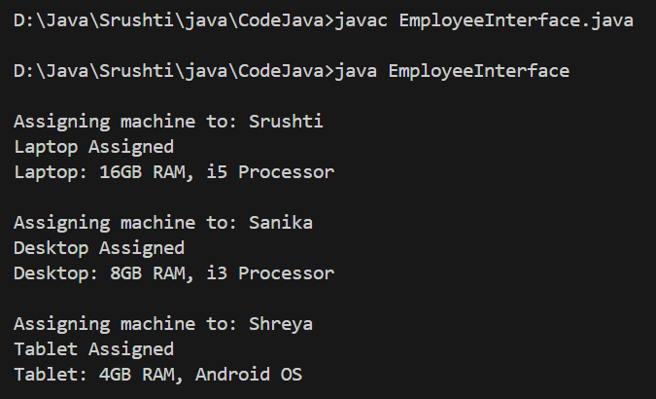
Practical Lab Experiment 6
6. Design application using String and StringBuilder
(Function to count the number of words in a given text, function to check the given string is palindrome or not.)

Code:
import java.util.Scanner;

public class StringFunctions {
// Function to count words
public static int countWords(String text) {
if (text == null || text.trim().isEmpty()) {
return 0;
}
String words[] = text.trim().split("\\s+");
return words.length;
}

// Function to check palindrome
public static boolean isPalindrome(String str) {
StringBuilder sb = new StringBuilder(str);
String reverse = sb.reverse().toString();
return str.equalsIgnoreCase(reverse);
}

public static void main(String[] args) {
Scanner sc = new Scanner(System.in);
// Word Count
System.out.println("Enter a sentence:");
String text = sc.nextLine();
System.out.println("Number of words: " + countWords(text));

// Palindrome Check
System.out.println("\nEnter a string to check palindrome:");
String word = sc.nextLine();

if (isPalindrome(word)) {
System.out.println(word + " is a Palindrome");
} else {
System.out.println(word + " is NOT a Palindrome");
}

sc.close();
}
}

Output:
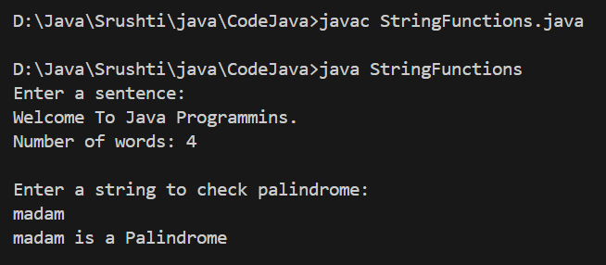

Practical Lab Experiment 7
7. A. Write a Java program to overload class method sum() – each method accepting 2 parameters – performing summation of either integer or floating point values.
B. Write a program to implement constructor overloading –
parameterized constructors, default constructor, copy constructor.
Code:
class Calculator {
// ----------------------- PART A -----------------------
int sum(int a, int b) {
return a + b;
}
float sum(float a, float b) {
return a + b;
}
}
class Student {
String name;
int age;
// ----------------------- PART B -----------------------
// Default constructor
Student() {
name = "Unknown";
age = 0;
}
// Parameterized constructor
Student(String name, int age) {
this.name = name;
this.age = age;
}
// Copy constructor
Student(Student s) {
this.name = s.name;
this.age = s.age;
}
void display() {
System.out.println("Name: " + name + ", Age: " + age);
}
}
public class OverloadingDemo {
public static void main(String[] args) {
System.out.println("=== PART A: Method Overloading ===");
Calculator calc = new Calculator();
System.out.println("Sum (int): " + calc.sum(10, 20));
System.out.println("Sum (float): " + calc.sum(12.5f, 7.5f));
System.out.println("\n=== PART B: Constructor Overloading ===");
// Default constructor
Student s1 = new Student();
s1.display();
// Parameterized constructor
Student s2 = new Student("Srushti", 21);
s2.display();
// Copy constructor
Student s3 = new Student(s2);
s3.display();
}
}
Output:
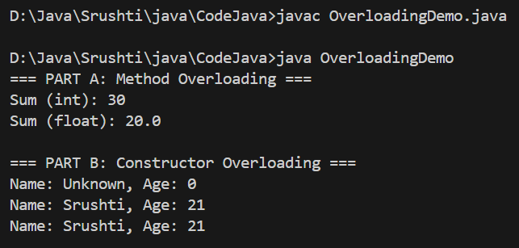

Practical Lab Experiment 8
8. Write a program to implement inheritance in Java. Show function overriding by creating objects of base and derived classes.
Code:
// Base Class
class Vehicle {
String brand;
Vehicle(String brand) {
this.brand = brand;
}
// Method to be overridden
void start() {
System.out.println("Vehicle is starting...");
}
void display() {
System.out.println("Brand: " + brand);
}
}
// Derived Class
class Car extends Vehicle {
int speed;
Car(String brand, int speed) {
super(brand); // calling base class constructor
this.speed = speed;
}
// Overriding start() method
@Override
void start() {
System.out.println("Car starts with a key ignition...");
}
// Car-specific method
void showSpeed() {
System.out.println("Top Speed: " + speed + " km/h");
}
}
// Main Class
public class InheritanceEx {
public static void main(String args[]) {
System.out.println("=== Base Class Object ===");
Vehicle v = new Vehicle("Honda");
v.display();
v.start(); // base class method
System.out.println("\n=== Derived Class Object ===");
Car c = new Car("Toyota", 180);
c.display(); // inherited method
c.start(); // overridden method
c.showSpeed();
}
}

Output:
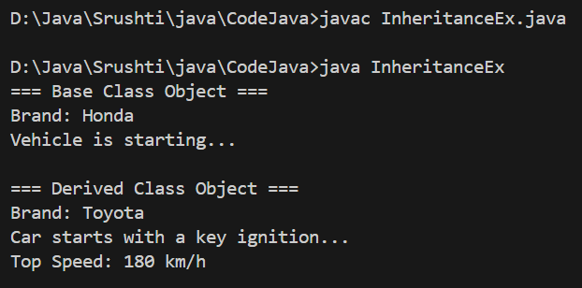

Practical Lab Experiment 9
9. Write a program in Java that creates a class called Student having three members name, age and enrolment_no.

Code:
class Student {
private String name;
private int age;
private int enrolment_no;
private static int counter = 0;
private static int enrolCounter = 1000;
public Student(String name, int age) {
this.name = name;
setAge(age);
enrolment_no = ++enrolCounter;
counter++;
}
public int getAge() {
return age;
}
public void setAge(int age) {
if (age >= 4 && age <= 40)
this.age = age;
else
this.age = 4;
}
public String getName() {
return name;
}
public int getEnrolmentNo() {
return enrolment_no;
}
public static int getStudentCount() {
return counter;
}
@Deprecated
protected void finalize() {
counter--;
}
public String toString() {
return "Student[Enrolment No: " + enrolment_no + ", Name: " + name + ", Age: " + age + "]";
}
}
public class StudentApp {
public static void removeStudent(Student[] students, int enrolNo) {
for (int i = 0; i < students.length; i++) {
if (students[i] != null && students[i].getEnrolmentNo() == enrolNo) {
students[i] = null;
System.gc(); // forces finalize()
return;
}
}
}
public static void main(String[] args) {
Student[] students = new Student[3];
students[0] = new Student("Srushti", 20);
students[1] = new Student("Shreya", 10);
students[2] = new Student("Snehal", 25);
System.out.println("All Students:");
for (Student s : students) {
System.out.println(s);
}
System.out.println("\nTotal Students: " + Student.getStudentCount());
int removeEnrolNo = students[1].getEnrolmentNo();
System.out.println("\nRemoving student with enrolment no: " + removeEnrolNo);
removeStudent(students, removeEnrolNo);
System.out.println("\nCurrent Students in Array:");
for (Student s : students) {
System.out.println(s);
}
System.out.println("\nStudent Count: " + Student.getStudentCount());
}
}

Output:
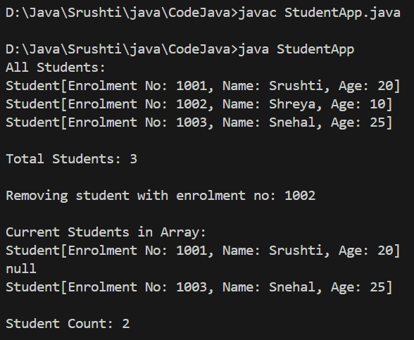

Practical Lab Experiment 10
10. Write a Java program that reads a line of integers and then displays each integer and the sum of all integers. (use StringTokenizer class)

Code:
import java.io.BufferedReader;
import java.io.InputStreamReader;
import java.util.StringTokenizer;

public class StringToken {

public static void main(String[] args) {

try {
// Reading a full line of input such as: 10 20 30 40 50
BufferedReader br = new BufferedReader(
new InputStreamReader(System.in));

System.out.println("Enter numbers separated by space: ");
String str = br.readLine();

// Tokenize the string using space as delimiter
StringTokenizer st = new StringTokenizer(str);

int num;
int sum = 0;

// Extract numbers from tokens and calculate sum
while (st.hasMoreTokens()) {
num = Integer.parseInt(st.nextToken());
System.out.println("Number: " + num);
sum += num;
}

System.out.println("Sum is: " + sum);
}
catch (Exception e) {
e.printStackTrace();
}
}
}

Output:
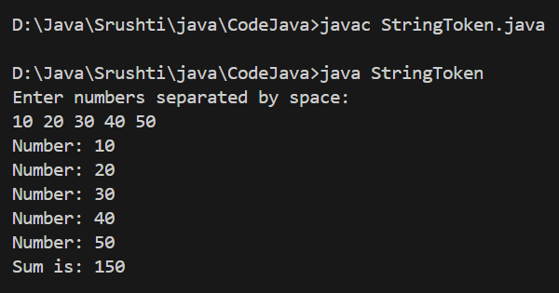

Practical Lab Experiment 11
11. Write a Java Program to test any five standard exceptions and User Defined Custom Exceptions using throw keyword

Code:
import java.util.*;
// User Defined Exception
class InvalidAgeException extends Exception {
InvalidAgeException(String msg) {
super(msg);
}
}
public class ExceptionDemo {
public static void main(String[] args) {
Scanner sc = new Scanner(System.in);
// 1. ArithmeticException
try {
System.out.print("Enter a number to divide 100: ");
int x = sc.nextInt();
int result = 100 / x;
System.out.println("Result = " + result);
} catch (ArithmeticException e) {
System.out.println("ArithmeticException: " + e.getMessage());
}
// 2. ArrayIndexOutOfBoundsException
try {
int[] arr = {10, 20, 30};
System.out.println("Accessing invalid index: " + arr[5]);
} catch (ArrayIndexOutOfBoundsException e) {
System.out.println("ArrayIndexOutOfBoundsException: " + e.getMessage());
}
// 3. NullPointerException
try {
String s = null;
System.out.println("Length = " + s.length());
} catch (NullPointerException e) {
System.out.println("NullPointerException: " + e.getMessage());
}
// 4. NumberFormatException
try {
String str = "abc";
int n = Integer.parseInt(str);
} catch (NumberFormatException e) {
System.out.println("NumberFormatException: " + e.getMessage());
}
// 5. InputMismatchException
try {
System.out.print("Enter an integer value: ");
int a = sc.nextInt();
} catch (InputMismatchException e) {
System.out.println("InputMismatchException: Please enter only integers.");
sc.next(); // clear wrong input
}
// User Defined Exception (using throw)
try {
System.out.print("Enter age (must be >= 18): ");
int age = sc.nextInt();
if (age < 18) {
throw new InvalidAgeException("Age must be 18 or above!");
}
System.out.println("Valid Age!");
} catch (InvalidAgeException e) {
System.out.println("Custom Exception: " + e.getMessage());
}
finally {
System.out.println("\nFinished Exception Demo.");
}
sc.close();
}
}

Output:
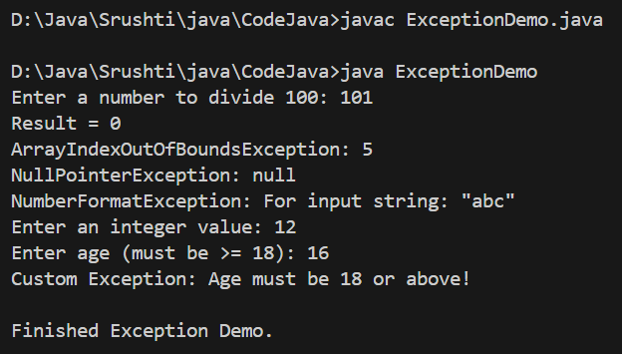

Practical Lab Experiment 12
12. Design java application using Collection in java using Array List Collection and perform operations on ArrayList.
Code:
import java.util.ArrayList;
import java.util.Scanner;
class Book {
int id;
String title;
boolean isIssued;
Book(int id, String title) {
this.id = id;
this.title = title;
this.isIssued = false;
}
public String toString() {
return id + " - " + title + " (" + (isIssued ? "Issued" : "Available") + ")";
}
}
class Library {
ArrayList<Book> books;
// Constructor loads initial books
Library() {
books = new ArrayList<>();
books.add(new Book(1, "Java Programming"));
books.add(new Book(2, "Data Structures"));
books.add(new Book(3, "Database Systems"));
}
void addBook(Book b) {
books.add(b);
System.out.println("Book added: " + b.title);
}
void issueBook(int id) {
for (Book b : books) {
if (b.id == id) {
if (!b.isIssued) {
b.isIssued = true;
System.out.println("Book issued: " + b.title);
} else {
System.out.println("Book already issued.");
}
return;
}
}
System.out.println("Book not found.");
}
void returnBook(int id) {
for (Book b : books) {
if (b.id == id) {
if (b.isIssued) {
b.isIssued = false;
System.out.println("Book returned: " + b.title);
} else {
System.out.println("Book was not issued.");
}
return;
}
}
System.out.println("Book not found.");
}
void showBooks() {
System.out.println("\n---- Library Books ----");
for (Book b : books) {
System.out.println(b);
}
}
}
public class LibraryApp {
public static void main(String[] args) {
Scanner sc = new Scanner(System.in);
Library lib = new Library();
int choice;
do {
System.out.println("\n===== Library Menu =====");
System.out.println("1. Show Books");
System.out.println("2. Add Book");
System.out.println("3. Issue Book");
System.out.println("4. Return Book");
System.out.println("5. Exit");
System.out.print("Enter your choice: ");
choice = sc.nextInt();
switch (choice) {
case 1:
lib.showBooks();
break;
case 2:
System.out.print("Enter Book ID: ");
int id = sc.nextInt();
sc.nextLine();
System.out.print("Enter Book Title: ");
String title = sc.nextLine();
lib.addBook(new Book(id, title));
break;
case 3:
System.out.print("Enter Book ID to issue: ");
lib.issueBook(sc.nextInt());
break;
case 4:
System.out.print("Enter Book ID to return: ");
lib.returnBook(sc.nextInt());
break;
case 5:
System.out.println("Exiting...");
break;
default:
System.out.println("Invalid choice.");
}
} while (choice != 5);
sc.close();
}
}
Output:
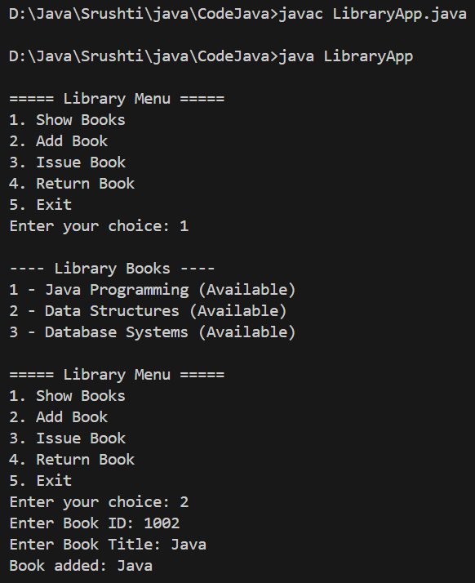
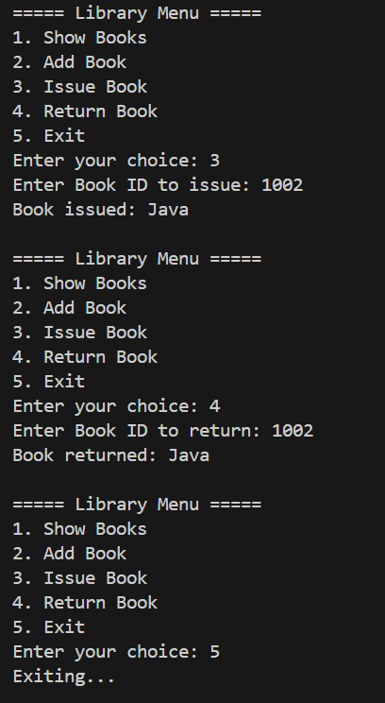

Practical Lab Experiment 13
13. Design java application using Collection in java using Linked List Collection and perform operations on Linked List

Code:
import java.util.LinkedList;
import java.util.ListIterator;
import java.util.Scanner;

public class LinkedListDemo {

public static void main(String[] args) {

LinkedList<String> list = new LinkedList<>();
Scanner sc = new Scanner(System.in);
int choice;
do {
System.out.println("\n------ LINKED LIST OPERATIONS ------");
System.out.println("1. Add Element");
System.out.println("2. Insert Element at Position");
System.out.println("3. Remove Element");
System.out.println("4. Update Element");
System.out.println("5. Search Element");
System.out.println("6. Display Forward");
System.out.println("7. Display Backward");
System.out.println("8. Exit");
System.out.print("Enter choice: ");
choice = sc.nextInt();
sc.nextLine(); // Consume newline

switch (choice) {

case 1:
System.out.print("Enter element to add: ");
list.add(sc.nextLine());
break;
case 2:
System.out.print("Enter position (0-based index): ");
int pos = sc.nextInt();
sc.nextLine();
System.out.print("Enter element: ");
String ele = sc.nextLine();
if (pos >= 0 && pos <= list.size())
list.add(pos, ele);
else
System.out.println("Invalid position!");
break;
case 3:
System.out.print("Enter element to remove: ");
String rem = sc.nextLine();
if (list.remove(rem))
System.out.println("Element removed.");
else
System.out.println("Element not found.");
break;
case 4:
System.out.print("Enter old value: ");
String oldValue = sc.nextLine();
System.out.print("Enter new value: ");
String newValue = sc.nextLine();
if (list.contains(oldValue)) {
list.set(list.indexOf(oldValue), newValue);
System.out.println("Element updated.");
} else {
System.out.println("Element not found.");
}
break;
case 5:
System.out.print("Enter element to search: ");
String search = sc.nextLine();
if (list.contains(search))
System.out.println("Element found at index: " + list.indexOf(search));
else
System.out.println("Element not found.");
break;
case 6:
System.out.println("\nLinked List (Forward):");
for (String item : list)
System.out.println(item);
break;
case 7:
System.out.println("\nLinked List (Backward):");
ListIterator<String> itr = list.listIterator(list.size());
while (itr.hasPrevious())
System.out.println(itr.previous());
break;
case 8:
System.out.println("Exiting...");
break;
default:
System.out.println("Invalid choice.");
}

} while (choice != 8);

sc.close();
}
}

Output:
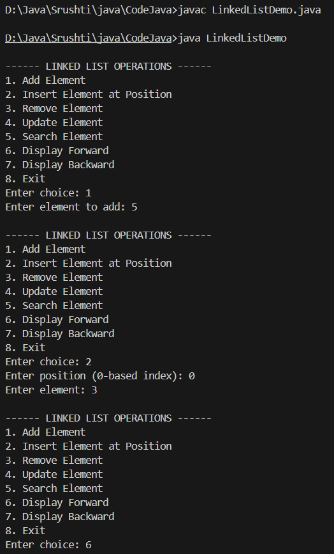
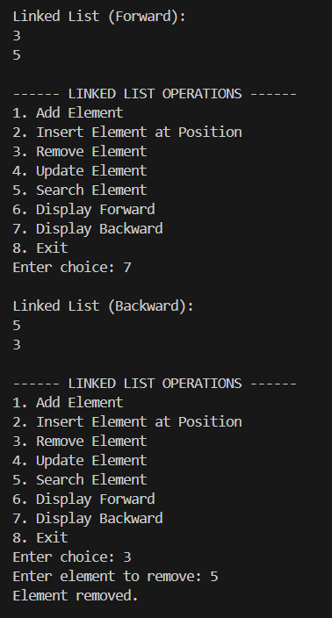
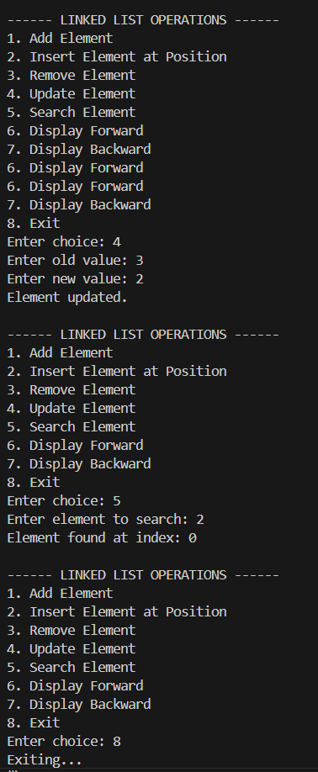
Practical Lab Experiment 14
14. Write a java program that loads names and phone numbers from a text file into a hash table where the data is organized as one line per record and each field in a record is separated by a tab (\t).
The program takes a name or phone number as input and prints the corresponding other value from the hash table

Code:
import java.io.*;
import java.util.*;
public class ContactLookup {
public static void main(String[] args) {
// HashMaps to store name -> phone and phone -> name
HashMap<String, String> nameToPhone = new HashMap<>();
HashMap<String, String> phoneToName = new HashMap<>();
// Load data from file
try (BufferedReader br = new BufferedReader(new FileReader("contact.txt"))){
String line;
while ((line = br.readLine()) != null) {
line = line.trim();
// Find last space or tab (before phone number)
int lastSpace = Math.max(line.lastIndexOf(" "), line.lastIndexOf("\t"));
if (lastSpace != -1) {
String name = line.substring(0, lastSpace).trim();
String phone = line.substring(lastSpace + 1).trim();
nameToPhone.put(name, phone);
phoneToName.put(phone, name);
}
}
} catch (IOException e) {
System.out.println("Error reading file: " + e.getMessage());
return;
}

// Take input from user
Scanner scanner = new Scanner(System.in);
System.out.print("Enter a name or phone number to search: ");
String input = scanner.nextLine().trim();

// Search in hash tables
if (nameToPhone.containsKey(input)) {
System.out.println("Phone number of " + input + " is: " + nameToPhone.get(input));

} else if (phoneToName.containsKey(input)) {
System.out.println("Name of phone number " + input + " is: " + phoneToName.get(input));

} else {
System.out.println("No record found for: " + input);
}

scanner.close();
}
}

Output:
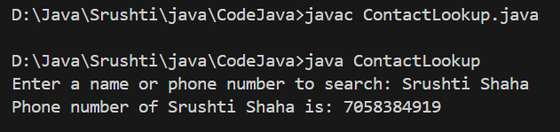

Practical Lab Experiment 15
15. Design and implement Networking application - Write a Java program (client) that sends a text message to another Java program (server), which receives and displays it. Use socket programming.

Code:
Server:
import java.io.BufferedReader;
import java.io.InputStreamReader;
import java.net.ServerSocket;
import java.net.Socket;

public class Server {
private static final int PORT = 9090;

public static void main(String[] args) {
try (ServerSocket serverSocket = new ServerSocket(PORT)) {
System.out.println("Server started, waiting for connection on port " + PORT + "...");

Socket clientSocket = serverSocket.accept();
System.out.println("Client connected: " + clientSocket.getInetAddress());

BufferedReader in = new BufferedReader(new InputStreamReader(clientSocket.getInputStream()));
String message = in.readLine();
System.out.println("Received message from client: " + message);
} catch (Exception e) {
System.err.println("Server error: " + e.getMessage());
}
}
}

Client:
import java.io.*;
import java.net.*;

public class Client {
public static void main(String[] args) throws IOException {
Socket socket = new Socket("localhost", 9090); // FIXED PORT
BufferedWriter out = new BufferedWriter(new OutputStreamWriter(socket.getOutputStream()));
BufferedReader reader = new BufferedReader(new InputStreamReader(System.in));
System.out.print("Enter message: ");
String message = reader.readLine();

out.write(message);
out.newLine();
out.flush();
out.close();
socket.close();
}
}
Output:
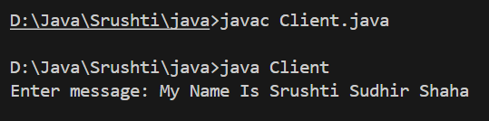
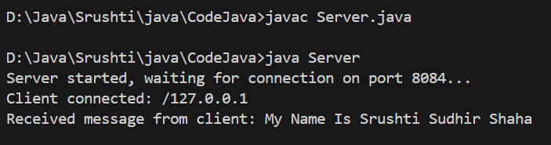
Practical Lab Experiment 16
16. A. Write a program to retrieve web page using URL class.
Code:
import java.io.BufferedReader;
import java.io.InputStreamReader;
import java.net.URL;
import java.net.HttpURLConnection;

public class WebPageRetrieve {

public static void main(String[] args) {
try {
URL url = new URL("https://www.cimdr.ac.in/");
HttpURLConnection connection = (HttpURLConnection) url.openConnection();

BufferedReader reader = new BufferedReader(
new InputStreamReader(connection.getInputStream()));

String line;
System.out.println("----- Web Page Content -----");

while ((line = reader.readLine()) != null) {
System.out.println(line);
}

reader.close();
}
catch (Exception e) {
e.printStackTrace();
}
}
}
Output:
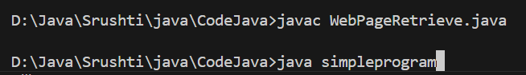
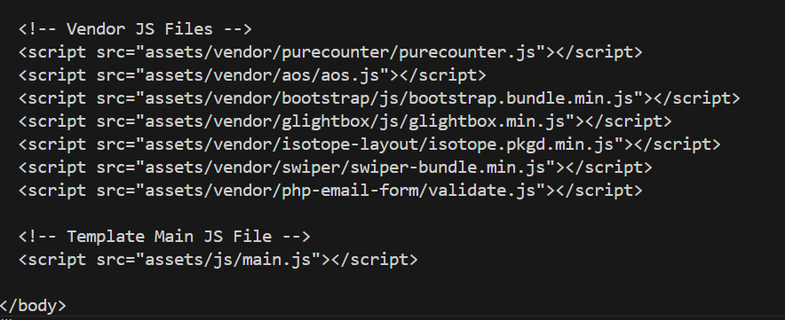

- Write a java program to obtain and display IP address from a given host
Code:
import java.net.InetAddress;

public class IPFromHost {
public static void main(String[] args) {
try {
// Host name (you can change this)
String host = "www.google.com";

// Get InetAddress object
InetAddress inet = InetAddress.getByName(host);

// Display output
System.out.println("Host Name : " + host);
System.out.println("IP Address : " + inet.getHostAddress());
}
catch (Exception e) {
System.out.println("Unable to resolve host.");
e.printStackTrace();
}
}
}

Output:

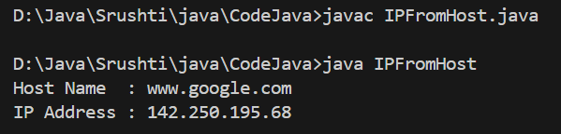

- Write a java program to display host name from ip address
Code:
import java.net.InetAddress;

public class HostFromIP {
public static void main(String[] args) {
try {
// Given IP address (you can change this)
String ip = "157.119.40.201";

// Convert IP → InetAddress
InetAddress inet = InetAddress.getByName(ip);

// Display output
System.out.println("IP Address : " + ip);
System.out.println("Host Name : " + inet.getHostName());
}
catch (Exception e) {
System.out.println("Unable to resolve IP address.");
e.printStackTrace();
}
}
}

Output:
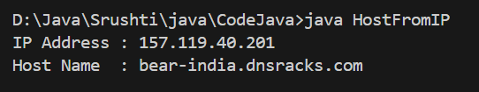

Practical Lab Experiment 17
17. Write a program to create Threads using both the methods.
Code:
class A implements Runnable
{
public void run() {
for (int i = 0; i < 10; i++) {
System.out.println(Thread.currentThread().getName() + " -> In Thread A");
try {
Thread.sleep(100);
} catch (InterruptedException e) {
e.printStackTrace();
}
}
}
}

class B implements Runnable
{
public void run() {
for (int i = 0; i < 10; i++) {
System.out.println(Thread.currentThread().getName() + " -> In Thread B");
try {
Thread.sleep(100);
} catch (InterruptedException e) {
System.out.println(e.getMessage());
}
}
}
}

public class method2Thread {

public static void main(String args[]) {

System.out.println("Main Thread Started");

// Create Runnable objects
Runnable objA = new A();
Runnable objB = new B();

// Create Thread objects
Thread t1 = new Thread(objA);
Thread t2 = new Thread(objB);
// Set names
t1.setName("Worker-A");
t2.setName("Worker-B");

// Set priorities
t1.setPriority(Thread.MAX_PRIORITY); // 10
t2.setPriority(Thread.MIN_PRIORITY); // 1

// Display main thread info
System.out.println("\n---- Main Thread Details ----");
System.out.println("State : " + Thread.currentThread().getState());
System.out.println("Name : " + Thread.currentThread().getName());
System.out.println("Priority : " + Thread.currentThread().getPriority());

// Display thread t1 info
System.out.println("\n---- Before Starting Thread t1 ----");
System.out.println("State : " + t1.getState());
System.out.println("Name : " + t1.getName());
System.out.println("Priority : " + t1.getPriority());

// Display thread t2 info
System.out.println("\n---- Before Starting Thread t2 ----");
System.out.println("State : " + t2.getState());
System.out.println("Name : " + t2.getName());
System.out.println("Priority : " + t2.getPriority());

// Start threads
t1.start();
t2.start();

// Display states after starting
System.out.println("\n---- After Starting Threads ----");
System.out.println("t1 State : " + t1.getState());
System.out.println("t2 State : " + t2.getState());

// join() so main waits for both threads
try {
t1.join();
t2.join();
} catch (InterruptedException e) {
System.out.println(e.getMessage());
}

System.out.println("\nMain Thread Finished");
}
}

Output:
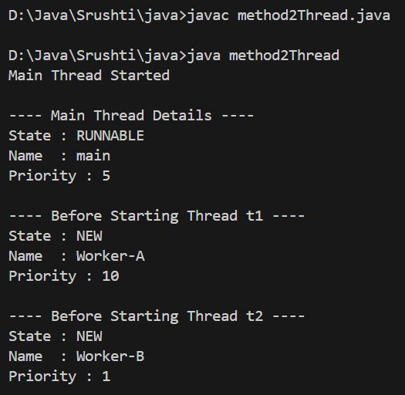
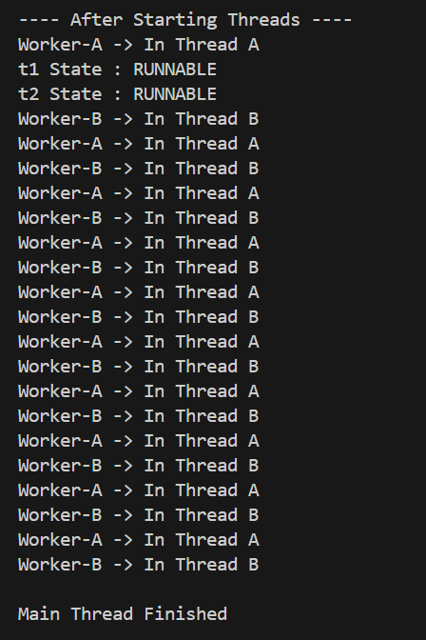
Practical Lab Experiment 18
18. Program on Multi-Threading:
Write a java program that implements a multi-thread application that has three threads.

Code:
import java.util.Random;

// Thread-1: Generates a random number every 1 second
class NumberGenerator extends Thread {
@Override
public void run() {
Random rand = new Random();

while (true) {
int num = rand.nextInt(100); // generate number 0–99
System.out.println("\nGenerated Number: " + num);

if (num % 2 == 0) {
// Even → Create Square Thread
new SquareThread(num).start();
} else {
// Odd → Create Cube Thread
new CubeThread(num).start();
}

try {
Thread.sleep(1000); // wait 1 second
} catch (InterruptedException e) {
System.out.println("Generator Interrupted.");
}
}
}
}

// Thread-2: Prints square of even numbers
class SquareThread extends Thread {
int number;

public SquareThread(int number) {
this.number = number;
}

@Override
public void run() {
System.out.println("Square of " + number + " = " + (number * number));
}
}

// Thread-3: Prints cube of odd numbers
class CubeThread extends Thread {
int number;

public CubeThread(int number) {
this.number = number;
}

@Override
public void run() {
System.out.println("Cube of " + number + " = " + (number * number * number));
}
}

public class MultiThread {
public static void main(String[] args) {
NumberGenerator generator = new NumberGenerator();
generator.start(); // start main generator thread
}
}
Output:
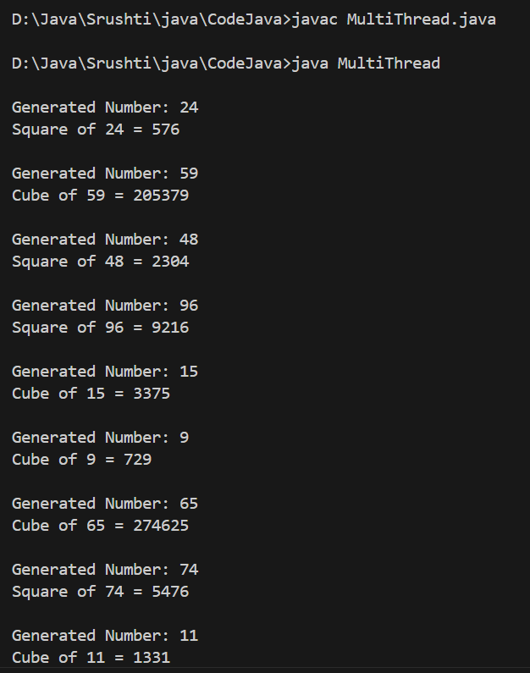

Practical Lab Experiment 19
19. Write a program to show synchronization in multiple threads.

Code:
class Pyramid {

// Synchronized method so only one thread can print at a time
synchronized void drawPyramid(char ch) {
for (int i = 1; i <= 5; i++) {
for (int j = 1; j <= i; j++) {
System.out.print(ch);
}
System.out.println();
}
System.out.println("-----------------------");
}
}
class PyramidThread extends Thread {
Pyramid p;
char symbol;

PyramidThread(Pyramid p, char symbol) {
this.p = p;
this.symbol = symbol;
}

public void run() {
p.drawPyramid(symbol);
}
}
public class SyncDemo {
public static void main(String[] args) {

Pyramid p = new Pyramid(); // Single shared object

PyramidThread t1 = new PyramidThread(p, '*');
PyramidThread t2 = new PyramidThread(p, '#');

t1.start();
t2.start();
}
}
Output:
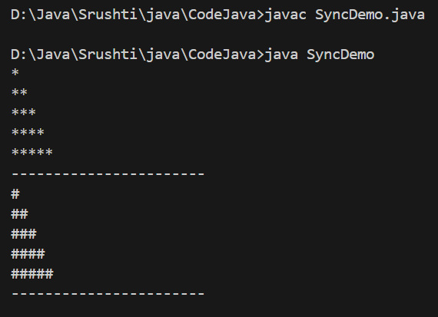

Practical Lab Experiment 20
20. Program on File Handling:
A. Write a Java program that reads on file name from the user, then displays information about whether the file exists, whether the file is readable, whether the file is writable, the type of file and the length of the file in bytes.

Code:
import java.io.File;
import java.util.Scanner;

public class FileInfo {
public static void main(String[] args) {

Scanner sc = new Scanner(System.in);
System.out.print("Enter file name: ");
String fileName = sc.nextLine();

File file = new File(fileName);

System.out.println("\n--- File Information ---");

if (file.exists()) {
System.out.println("File exists: Yes");
System.out.println("Readable: " + file.canRead());
System.out.println("Writable: " + file.canWrite());
System.out.println("File type: " + getFileExtension(file));
System.out.println("File size (bytes): " + file.length());
} else {
System.out.println("File exists: No");
}
sc.close();
}

// method to extract extension
private static String getFileExtension(File file) {
String name = file.getName();
int index = name.lastIndexOf('.');
if (index > 0) {
return name.substring(index + 1);
}
return "No extension";
}
}

Output:
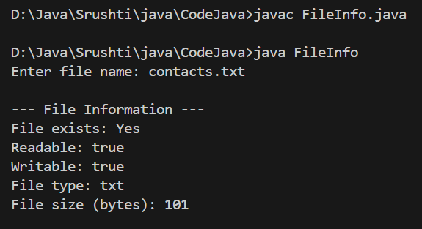

B. Also, write a program to write multiplication table of 4 in the file.
Code:
import java.io.*;
class WriteTable {
public static void main(String[] args) {
try {
FileWriter fw = new FileWriter("table4.txt");
for (int i = 1; i <= 10; i++) {
fw.write("4 x " + i + " = " + (4 * i) + "\n");
}
fw.close();
System.out.println("Done!");
} catch (Exception e) {
System.out.println(e);
}
}
}
Output:
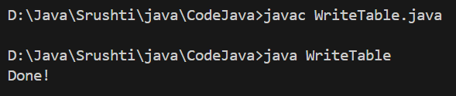
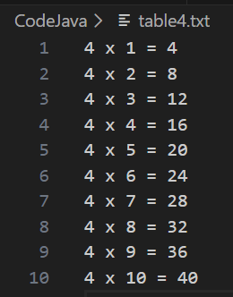
Practical Lab Experiment 21
21. Design GUI Based application using AWT, Swing and Event Handling.
Code:
import javax.swing.*;
import java.awt.*;
import java.awt.event.*;
public class TrafficLight extends JFrame implements ActionListener {
JRadioButton redBtn, yellowBtn, greenBtn;
ButtonGroup group;
TrafficPanel panel;
public TrafficLight() {
setTitle("Traffic Light System");
setSize(350, 400);
setLayout(new BorderLayout());
// Panel for buttons
JPanel buttonPanel = new JPanel();
buttonPanel.setLayout(new FlowLayout());
redBtn = new JRadioButton("Red");
yellowBtn = new JRadioButton("Yellow");
greenBtn = new JRadioButton("Green");
group = new ButtonGroup();
group.add(redBtn);
group.add(yellowBtn);
group.add(greenBtn);
buttonPanel.add(redBtn);
buttonPanel.add(yellowBtn);
buttonPanel.add(greenBtn);
add(buttonPanel, BorderLayout.SOUTH);
// Add drawing panel
panel = new TrafficPanel();
add(panel, BorderLayout.CENTER);
// Add listeners
redBtn.addActionListener(this);
yellowBtn.addActionListener(this);
greenBtn.addActionListener(this);
setDefaultCloseOperation(JFrame.EXIT_ON_CLOSE);
setVisible(true);
}
public void actionPerformed(ActionEvent e) {
if (redBtn.isSelected())
panel.setLightColor("RED");
else if (yellowBtn.isSelected())
panel.setLightColor("YELLOW");
else if (greenBtn.isSelected())
panel.setLightColor("GREEN");
}
// Inner class for drawing the traffic light
class TrafficPanel extends JPanel {
String currentColor = "";
public TrafficPanel() {
// REMOVE TOP SPACE
setBorder(BorderFactory.createEmptyBorder(0, 0, 0, 0));
}
public void setLightColor(String color) {
currentColor = color;
repaint();
}
protected void paintComponent(Graphics g) {
super.paintComponent(g);
// Draw outline (moved UP)
g.setColor(Color.BLACK);
g.fillRect(100, 10, 120, 260);
// Red light (moved UP)
g.setColor(currentColor.equals("RED") ? Color.RED : Color.DARK_GRAY);
g.fillOval(120, 30, 80, 80);
// Yellow light (moved UP)
g.setColor(currentColor.equals("YELLOW") ? Color.YELLOW : Color.DARK_GRAY);
g.fillOval(120, 110, 80, 80);
// Green light (moved UP)
g.setColor(currentColor.equals("GREEN") ? Color.GREEN : Color.DARK_GRAY);
g.fillOval(120, 190, 80, 80);
}
}
public static void main(String[] args) {
new TrafficLight();
}
}
Output:
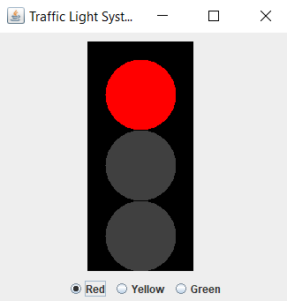
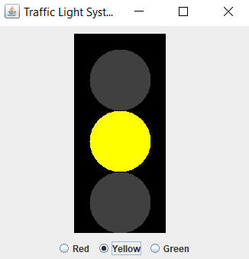

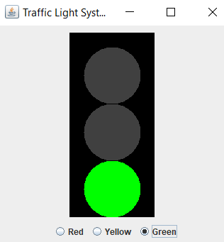

Practical Lab Experiment 22
22. Event Handling: Write a Java program that handles all mouse events and shows the event name at the center of the window when a mouse event is fired. (Use adapter classes).

Code:
import java.awt.*;
import java.awt.event.*;
import javax.swing.*;

public class MouseEventExample extends JFrame {

String msg = "";

public MouseEventExample() {
setTitle("Mouse Event Example");
setSize(400, 300);
setDefaultCloseOperation(JFrame.EXIT_ON_CLOSE);

addMouseListener(new MouseAdapter() {
public void mouseClicked(MouseEvent e) {
msg = "Mouse Clicked";
getContentPane().setBackground(Color.YELLOW);
repaint();
}
public void mousePressed(MouseEvent e) {
msg = "Mouse Pressed";
getContentPane().setBackground(Color.CYAN);
repaint();
}
public void mouseReleased(MouseEvent e) {
msg = "Mouse Released";
getContentPane().setBackground(Color.PINK);
repaint();
}
public void mouseEntered(MouseEvent e) {
msg = "Mouse Entered";
getContentPane().setBackground(Color.GREEN);
repaint();
}
public void mouseExited(MouseEvent e) {
msg = "Mouse Exited";
getContentPane().setBackground(Color.LIGHT_GRAY);
repaint();
}
});
}

public void paint(Graphics g) {
super.paint(g);
g.setFont(new Font("Arial", Font.BOLD, 22));
g.drawString(msg, 120, 150);
}

public static void main(String[] args) {
new MouseEventExample().setVisible(true);
}
}

Output:
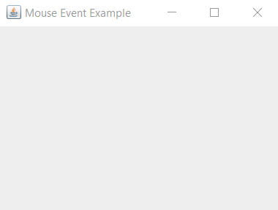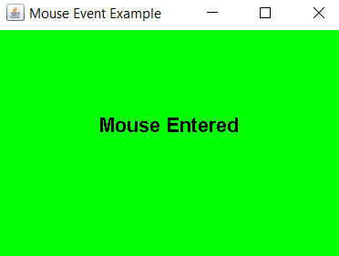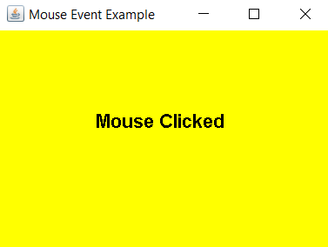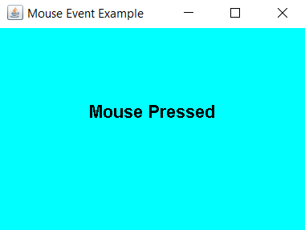
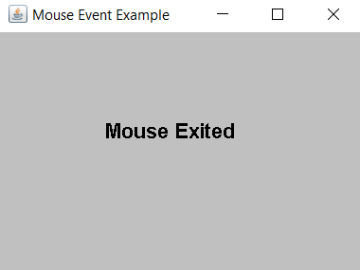

Practical Lab Experiment 23
23. Write a program that creates a user interface to perform integer divisions.

Code:
import javax.swing.*;
import java.awt.*;
import java.awt.event.*;
public class DivisionUI extends JFrame implements ActionListener {
JTextField num1Field, num2Field, resultField;
JButton divideBtn;
public DivisionUI() {
setTitle("Integer Division");
setSize(300, 200);
setLayout(new FlowLayout());
add(new JLabel("Num1:"));
num1Field = new JTextField(10);
add(num1Field);
add(new JLabel("Num2:"));
num2Field = new JTextField(10);
add(num2Field);
divideBtn = new JButton("Divide");
add(divideBtn);
divideBtn.addActionListener(this);
add(new JLabel("Result:"));
resultField = new JTextField(10);
resultField.setEditable(false);
add(resultField);
setDefaultCloseOperation(JFrame.EXIT_ON_CLOSE);
setVisible(true);
}

public void actionPerformed(ActionEvent e) {
try {
int num1 = Integer.parseInt(num1Field.getText());
int num2 = Integer.parseInt(num2Field.getText());
int result = num1 / num2;
resultField.setText(String.valueOf(result));
} catch (NumberFormatException ex) {
JOptionPane.showMessageDialog(this,
"Please enter valid integers!",
"Number Format Error",
JOptionPane.ERROR_MESSAGE);
} catch (ArithmeticException ex) {
JOptionPane.showMessageDialog(this,
"Cannot divide by Zero!",
"Arithmetic Error",
JOptionPane.ERROR_MESSAGE);
}
}

public static void main(String[] args) {
new DivisionUI();
}
}

Output:
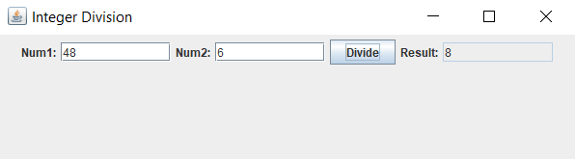

Practical Lab Experiment 24
24. Write a java program to implement basic calculator using grid layout

Code:
import java.awt.*;
import java.awt.event.*;
import javax.swing.*;
import javax.swing.border.EmptyBorder;

class GuiForm extends JFrame implements ActionListener {

JLabel lblNum1, lblNum2, lblResult;
JTextField jNum1, jNum2;
JButton btnAdd, btnSub, btnMult, btnDivide, btnMod;

GuiForm() {

setTitle("Styled Calculator");
setSize(400, 350);

// Main Panel with padding
JPanel mainPanel = new JPanel(new GridLayout(6, 2, 10, 15));
mainPanel.setBorder(new EmptyBorder(15, 15, 15, 15));
mainPanel.setBackground(new Color(240, 248, 255)); // very light blue

// Fonts
Font labelFont = new Font("Segoe UI", Font.BOLD, 14);
Font btnFont = new Font("Segoe UI", Font.PLAIN, 14);

lblNum1 = new JLabel("Enter Number 1:");
lblNum1.setFont(labelFont);

lblNum2 = new JLabel("Enter Number 2:");
lblNum2.setFont(labelFont);

jNum1 = new JTextField(10);
jNum1.setFont(btnFont);

jNum2 = new JTextField(10);
jNum2.setFont(btnFont);

btnAdd = new JButton("Add");
btnSub = new JButton("Subtract");
btnMult = new JButton("Multiply");
btnDivide = new JButton("Divide");
btnMod = new JButton("Modulus");

JButton[] buttons = {btnAdd, btnSub, btnMult, btnDivide, btnMod};

// Style buttons
for (JButton btn : buttons) {
btn.setBackground(new Color(70, 130, 180)); // steel blue
btn.setForeground(Color.WHITE);
btn.setFont(btnFont);
btn.setFocusPainted(false);
btn.setBorder(BorderFactory.createLineBorder(new Color(30, 60, 90), 2));
}

lblResult = new JLabel("Result will appear here");
lblResult.setFont(new Font("Segoe UI", Font.BOLD, 14));
lblResult.setForeground(new Color(128, 0, 0)); // dark red

// Add components in Grid Layout
mainPanel.add(lblNum1);
mainPanel.add(jNum1);

mainPanel.add(lblNum2);
mainPanel.add(jNum2);

mainPanel.add(btnAdd);
mainPanel.add(btnSub);

mainPanel.add(btnMult);
mainPanel.add(btnDivide);

mainPanel.add(btnMod);
mainPanel.add(lblResult);

add(mainPanel);

// Action Listeners
for (JButton btn : buttons) btn.addActionListener(this);

setDefaultCloseOperation(JFrame.EXIT_ON_CLOSE);
setVisible(true);
}
public void actionPerformed(ActionEvent e) {

int n1 = Integer.parseInt(jNum1.getText());
int n2 = Integer.parseInt(jNum2.getText());

if (e.getSource() == btnAdd)
lblResult.setText("Addition = " + (n1 + n2));

else if (e.getSource() == btnSub)
lblResult.setText("Subtraction = " + (n1 - n2));

else if (e.getSource() == btnMult)
lblResult.setText("Multiplication = " + (n1 * n2));

else if (e.getSource() == btnDivide)
lblResult.setText("Division = " + (n1 / n2));

else if (e.getSource() == btnMod)
lblResult.setText("Modulus = " + (n1 % n2));
}
}
public class TestGUI {
public static void main(String[] args) {
new GuiForm();
}
}

Output:
